Name: Total Points: ________ / 60pts.
Beginning Photo Project #1
You will take photos around the school that demonstrate the elements and principles of design. Insert photos into this document (as shown in class) and resize them accordingly. Photos should be clear and in focus, and demonstrate ONE CLEAR EXAMPLE of the following concepts:

LINE: ______/ 5pts.

SHAPE/FORM: ______/ 5pts.

COLOR: ______/ 5pts.

VALUE: ______/ 5pts.

TEXTURE: ______/ 5pts.

SPACE/PERSPECTIVE: ______/ 5pts.

PETTERN: ______/ 5pts.

RHYTHM/MOVEMENT: ______/ 5pts.

BALANCE: ______/ 5pts.

UNITY: ______/ 5pts.

EMPHASIS: ______/ 5pts.

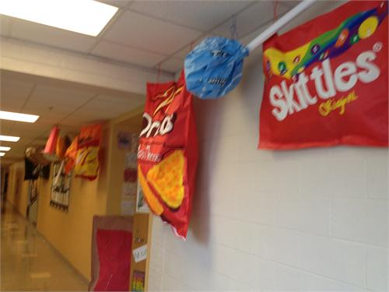
Proportion/Scale: ______/ 5pts.

